MACHINE LEARNING INDEX
Sr. No. | Practical Title | Date | Sign
2 | Data Preprocessing: Handling Missing Values and Encoding Categorical Variables
3 | Data Normalization and Standardization Techniques
4 | Implementation of Simple Linear Regression
5 | Implementation of Multiple Linear Regression
6 | Polynomial Regression on a Sample Dataset
7 | Logistic Regression for Binary Classification
8 | k-Nearest Neighbors (k-NN) Classifier Implementation
9 | Decision Tree Classifier Implementation
10 | Naive Bayes Classification
12 | Random Forest Classifier Implementation

PRACTICAL NO 2

Aim: To understand and implement data preprocessing techniques — handling missing values using imputation and encoding categorical variables using Label Encoding and One-Hot Encoding.
Objective: Apply preprocessing steps on a sample dataset to prepare it for machine learning by treating null values and converting non-numeric features to numeric form.
Code
import pandas as pd
import numpy as np
from sklearn.impute import SimpleImputer
from sklearn.preprocessing import LabelEncoder
data = {
'Age': [25, np.nan, 30, 22, np.nan, 28],
'Salary': [50000, 60000, np.nan, 45000, 70000, np.nan],
'Gender': ['Male', 'Female', 'Female', np.nan, 'Male', 'Female'],
'City': ['Mumbai', 'Pune', 'Delhi', 'Mumbai', np.nan, 'Pune']
}
df = pd.DataFrame(data)
print("Original DataFrame:\n", df)
print("\nMissing values:\n", df.isnull().sum())
num_imputer = SimpleImputer(strategy='mean')
df[['Age', 'Salary']] = num_imputer.fit_transform(df[['Age', 'Salary']])
cat_imputer = SimpleImputer(strategy='most_frequent')
df[['Gender', 'City']] = cat_imputer.fit_transform(df[['Gender', 'City']])
print("\nAfter Imputation:\n", df)
le = LabelEncoder()
df['Gender_Encoded'] = le.fit_transform(df['Gender'])
print("\nLabel Encoded Gender:", df['Gender_Encoded'].values)
df_encoded = pd.get_dummies(df, columns=['City'], drop_first=False)
print("\nAfter One-Hot Encoding:\n", df_encoded)

Output:
Original DataFrame:
Age Salary Gender City
0 25.0 50000.0 Male Mumbai
1 NaN 60000.0 Female Pune
2 30.0 NaN Female Delhi
3 22.0 45000.0 NaN Mumbai
4 NaN 70000.0 Male NaN
5 28.0 NaN Female Pune
Missing values:
Age 2
Salary 2
Gender 1
City 1
dtype: int64
After Imputation:
Age Salary Gender City
0 25.00 50000.0 Male Mumbai
1 26.25 60000.0 Female Pune
2 30.00 56250.0 Female Delhi
3 22.00 45000.0 Female Mumbai
4 26.25 70000.0 Male Mumbai
5 28.00 56250.0 Female Pune
Label Encoded Gender: [1 0 0 0 1 0]
After One-Hot Encoding:
Age Salary Gender Gender_Encoded City_Delhi City_Mumbai City_Pune
0 25.00 50000.0 Male 1 False True False
1 26.25 60000.0 Female 0 False False True
2 30.00 56250.0 Female 0 True False False
3 22.00 45000.0 Female 0 False True False
4 26.25 70000.0 Male 1 False True False
5 28.00 56250.0 Female 0 False False True

Result: Missing values were filled using mean and mode imputation. Label Encoding and One-Hot Encoding were applied successfully to convert categorical data into numeric format.

PRACTICAL NO 3

Aim: To apply and compare data normalization (Min-Max Scaling) and standardization (Z-score Standardization) on a dataset.
Objective: Understand the effect of scaling techniques on data distribution using MinMaxScaler and StandardScaler.
Code
import numpy as np
import pandas as pd
import matplotlib.pyplot as plt
from sklearn.preprocessing import MinMaxScaler, StandardScaler
data = {
'Age': [22, 25, 47, 52, 46, 56, 35, 29],
'Salary': [25000, 35000, 75000, 90000, 65000, 100000, 55000, 40000],
'Score': [60, 72, 88, 95, 80, 98, 77, 68]
}
df = pd.DataFrame(data)
print("Original Data:\n", df)
minmax = MinMaxScaler()
df_normalized = pd.DataFrame(minmax.fit_transform(df), columns=df.columns)
print("\nNormalized Data (Min-Max):\n", df_normalized.round(4))
standard = StandardScaler()
df_standardized = pd.DataFrame(standard.fit_transform(df), columns=df.columns)
print("\nStandardized Data (Z-score):\n", df_standardized.round(4))
fig, axes = plt.subplots(1, 3, figsize=(15, 5))
for ax, title, data_plot in zip(axes,
['Original', 'Normalized', 'Standardized'],
[df, df_normalized, df_standardized]):
ax.boxplot(data_plot.values, labels=data_plot.columns)
ax.set_title(title + ' Data')
ax.grid(True, alpha=0.3)
plt.tight_layout()
plt.show()

Output:
Original Data:
Age Salary Score
0 22 25000 60
1 25 35000 72
2 47 75000 88
3 52 90000 95
4 46 65000 80
5 56 100000 98
6 35 55000 77
7 29 40000 68
Normalized Data (Min-Max):
Age Salary Score
0 0.0000 0.0000 0.0000
1 0.0882 0.1333 0.3158
2 0.7353 0.6667 0.7368
3 0.8824 0.8667 0.9211
4 0.7059 0.5333 0.5263
5 1.0000 1.0000 1.0000
6 0.3824 0.4000 0.4474
7 0.2059 0.2000 0.2105
Standardized Data (Z-score):
Age Salary Score
0 -1.4045 -1.4219 -1.5931
1 -1.1567 -1.0228 -0.6251
2 0.6610 0.5737 0.6655
3 1.0741 1.1724 1.2301
4 0.5783 0.1746 0.0202
5 1.4045 1.5716 1.4721
6 -0.3305 -0.2245 -0.2218
7 -0.8262 -0.8232 -0.9478
Traceback (most recent call last):
File "C:\Srinith_Samala\Machine blackbook\create_ml_practicals.py", line 33, in run_code
exec(code_str, {'__builtins__': __builtins__})
~~~~^^^^^^^^^^^^^^^^^^^^^^^^^^^^^^^^^^^^^^^^^^
File "<string>", line 26, in <module>
File "C:\Users\Srinith Samala\AppData\Roaming\Python\Python314\site-packages\matplotlib\_api\deprecation.py", line 477, in wrapper
return func(*args, **kwargs)
File "C:\Users\Srinith Samala\AppData\Roaming\Python\Python314\site-packages\matplotlib\__init__.py", line 1531, in inner
return func(
ax,
*map(cbook.sanitize_sequence, args),
**{k: cbook.sanitize_sequence(v) for k, v in kwargs.items()})
TypeError: Axes.boxplot() got an unexpected keyword argument 'labels'. Did you mean 'label'?

Result: Min-Max Normalization scaled all features to [0,1] range, while Z-score Standardization transformed data to have mean=0 and std=1. The box plots clearly showed the effect of each scaling technique.

PRACTICAL NO 4

Aim: To implement Simple Linear Regression to predict a continuous output variable based on a single input feature.
Objective: Build a linear regression model using Scikit-learn, evaluate using R² score and MSE, and visualize the regression line.
Code
import numpy as np
import pandas as pd
import matplotlib.pyplot as plt
from sklearn.linear_model import LinearRegression
from sklearn.model_selection import train_test_split
from sklearn.metrics import mean_squared_error, r2_score
data = {
'Hours_Studied': [1, 2, 3, 4, 5, 6, 7, 8, 9, 10],
'Exam_Score': [35, 45, 50, 60, 65, 70, 75, 85, 90, 95]
}
df = pd.DataFrame(data)
print("Dataset:\n", df)
X = df[['Hours_Studied']]
y = df['Exam_Score']
X_train, X_test, y_train, y_test = train_test_split(X, y, test_size=0.2, random_state=42)
model = LinearRegression()
model.fit(X_train, y_train)
print(f"\nIntercept: {model.intercept_:.4f}")
print(f"Slope: {model.coef_[0]:.4f}")
y_pred = model.predict(X_test)
print("\nPredictions vs Actual:")
for pred, actual in zip(y_pred, y_test):
print(f" Predicted: {pred:.2f} | Actual: {actual}")
mse = mean_squared_error(y_test, y_pred)
r2 = r2_score(y_test, y_pred)
print(f"\nMSE: {mse:.4f}")
print(f"R2: {r2:.4f}")
plt.figure(figsize=(8, 5))
plt.scatter(X, y, color='blue', label='Actual Data', s=60)
plt.plot(X, model.predict(X), color='red', linewidth=2, label='Regression Line')
plt.title('Simple Linear Regression: Hours vs Score')
plt.xlabel('Hours Studied')
plt.ylabel('Exam Score')
plt.legend()
plt.grid(True, alpha=0.3)
plt.show()

Output:
Dataset:
Hours_Studied Exam_Score
0 1 35
1 2 45
2 3 50
3 4 60
4 5 65
5 6 70
6 7 75
7 8 85
8 9 90
9 10 95
Intercept: 30.6034
Slope: 6.5948
Predictions vs Actual:
Predicted: 89.96 | Actual: 90
Predicted: 43.79 | Actual: 45
MSE: 0.7292
R2: 0.9986

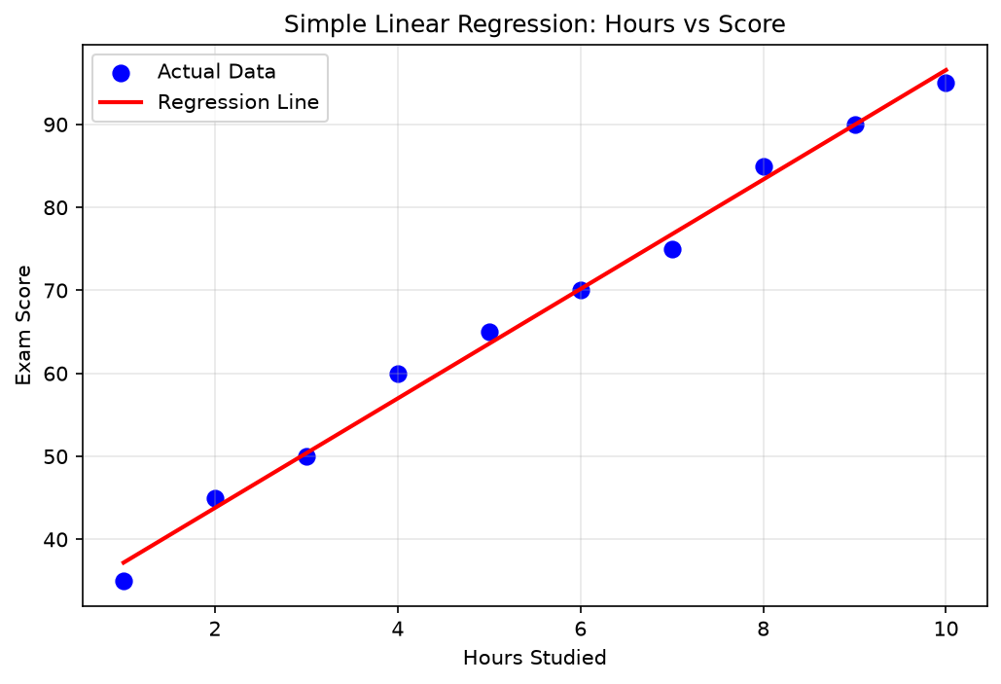
Result: Simple Linear Regression model was trained successfully. The regression line fits the data well. MSE and R2 score indicate good model performance.

PRACTICAL NO 5
Aim: To implement Multiple Linear Regression to predict a continuous output variable using more than one input feature.
Objective: Build a multiple linear regression model using Scikit-learn on a house price dataset, evaluate it using R2, MSE, and RMSE.
Code
import numpy as np
import pandas as pd
import matplotlib.pyplot as plt
from sklearn.linear_model import LinearRegression
from sklearn.model_selection import train_test_split
from sklearn.metrics import mean_squared_error, r2_score
data = {
'Area_sqft': [1000, 1500, 2000, 2500, 3000, 3500, 4000, 4500, 5000, 5500],
'Bedrooms': [2, 3, 3, 4, 4, 5, 5, 6, 6, 7],
'Age_years': [10, 8, 15, 5, 12, 3, 7, 2, 20, 1],
'Price_lakhs': [30, 45, 55, 70, 80, 100, 120, 140, 150, 180]
}
df = pd.DataFrame(data)
print("Dataset:\n", df)
X = df[['Area_sqft', 'Bedrooms', 'Age_years']]
y = df['Price_lakhs']
X_train, X_test, y_train, y_test = train_test_split(X, y, test_size=0.3, random_state=42)
model = LinearRegression()
model.fit(X_train, y_train)
print(f"\nIntercept: {model.intercept_:.4f}")
for feat, coef in zip(X.columns, model.coef_):
print(f" {feat}: {coef:.4f}")
y_pred = model.predict(X_test)
mse = mean_squared_error(y_test, y_pred)
rmse = np.sqrt(mse)
r2 = r2_score(y_test, y_pred)
print(f"\nMSE: {mse:.4f}")
print(f"RMSE: {rmse:.4f}")
print(f"R2: {r2:.4f}")
plt.figure(figsize=(8, 5))
plt.scatter(y_test, y_pred, color='steelblue', edgecolors='black', s=80)
plt.plot([y_test.min(), y_test.max()], [y_test.min(), y_test.max()], 'r--', linewidth=2, label='Ideal Line')
plt.xlabel('Actual Price (Lakhs)')
plt.ylabel('Predicted Price (Lakhs)')
plt.title('Multiple Linear Regression: Actual vs Predicted')
plt.legend()
plt.grid(True, alpha=0.3)
plt.show()

Output:
Dataset:
Area_sqft Bedrooms Age_years Price_lakhs
0 1000 2 10 30
1 1500 3 8 45
2 2000 3 15 55
3 2500 4 5 70
4 3000 4 12 80
5 3500 5 3 100
6 4000 5 7 120
7 4500 6 2 140
8 5000 6 20 150
9 5500 7 1 180
Intercept: 15.6098
Area_sqft: 0.0393
Bedrooms: -8.0762
Age_years: -1.2964
MSE: 85.8869
RMSE: 9.2675
R2: 0.9533

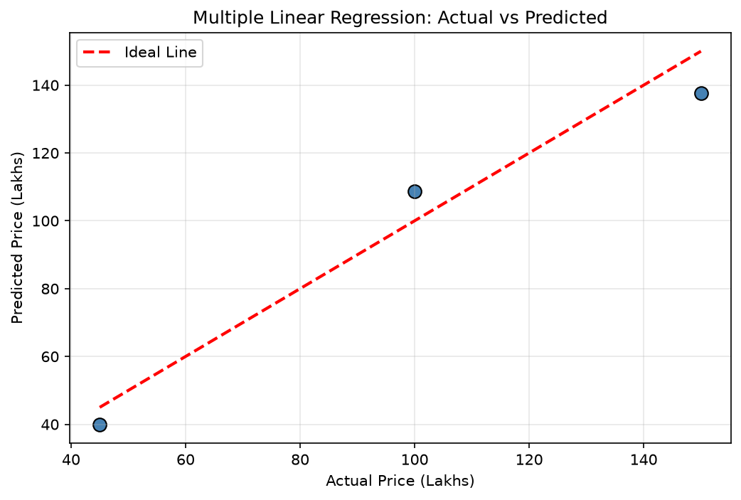
Result: Multiple Linear Regression was implemented using Area, Bedrooms, and Age as features. R2, MSE, and RMSE were computed. The scatter plot showed the model prediction accuracy.

PRACTICAL NO 6
Aim: To implement Polynomial Regression to model non-linear relationships between variables.
Objective: Transform features using PolynomialFeatures and fit polynomial curves; compare multiple degrees.
Code
import numpy as np
import matplotlib.pyplot as plt
from sklearn.linear_model import LinearRegression
from sklearn.preprocessing import PolynomialFeatures
from sklearn.pipeline import Pipeline
from sklearn.metrics import r2_score, mean_squared_error
np.random.seed(42)
X = np.linspace(-3, 3, 50).reshape(-1, 1)
y = 2*X**3 - X**2 + 3*X + np.random.normal(0, 3, X.shape)
degrees = [1, 2, 3, 5]
plt.figure(figsize=(14, 5))
for i, degree in enumerate(degrees, 1):
model = Pipeline([
('poly', PolynomialFeatures(degree=degree)),
('linear', LinearRegression())
])
model.fit(X, y)
y_pred = model.predict(X)
r2 = r2_score(y, y_pred)
plt.subplot(1, 4, i)
plt.scatter(X, y, color='blue', s=20, label='Data')
plt.plot(X, y_pred, color='red', linewidth=2, label=f'Degree {degree}')
plt.title(f'Degree {degree}\nR2={r2:.3f}')
plt.xlabel('X')
plt.ylabel('Y')
plt.legend(fontsize=6)
plt.grid(True, alpha=0.3)
plt.tight_layout()
plt.show()
best_model = Pipeline([('poly', PolynomialFeatures(degree=3)), ('linear', LinearRegression())])
best_model.fit(X, y)
y_best = best_model.predict(X)
print(f"Best Model (Degree 3) -- R2: {r2_score(y, y_best):.4f} | MSE: {mean_squared_error(y, y_best):.4f}")

Output:
Best Model (Degree 3) -- R2: 0.9899 | MSE: 6.8876

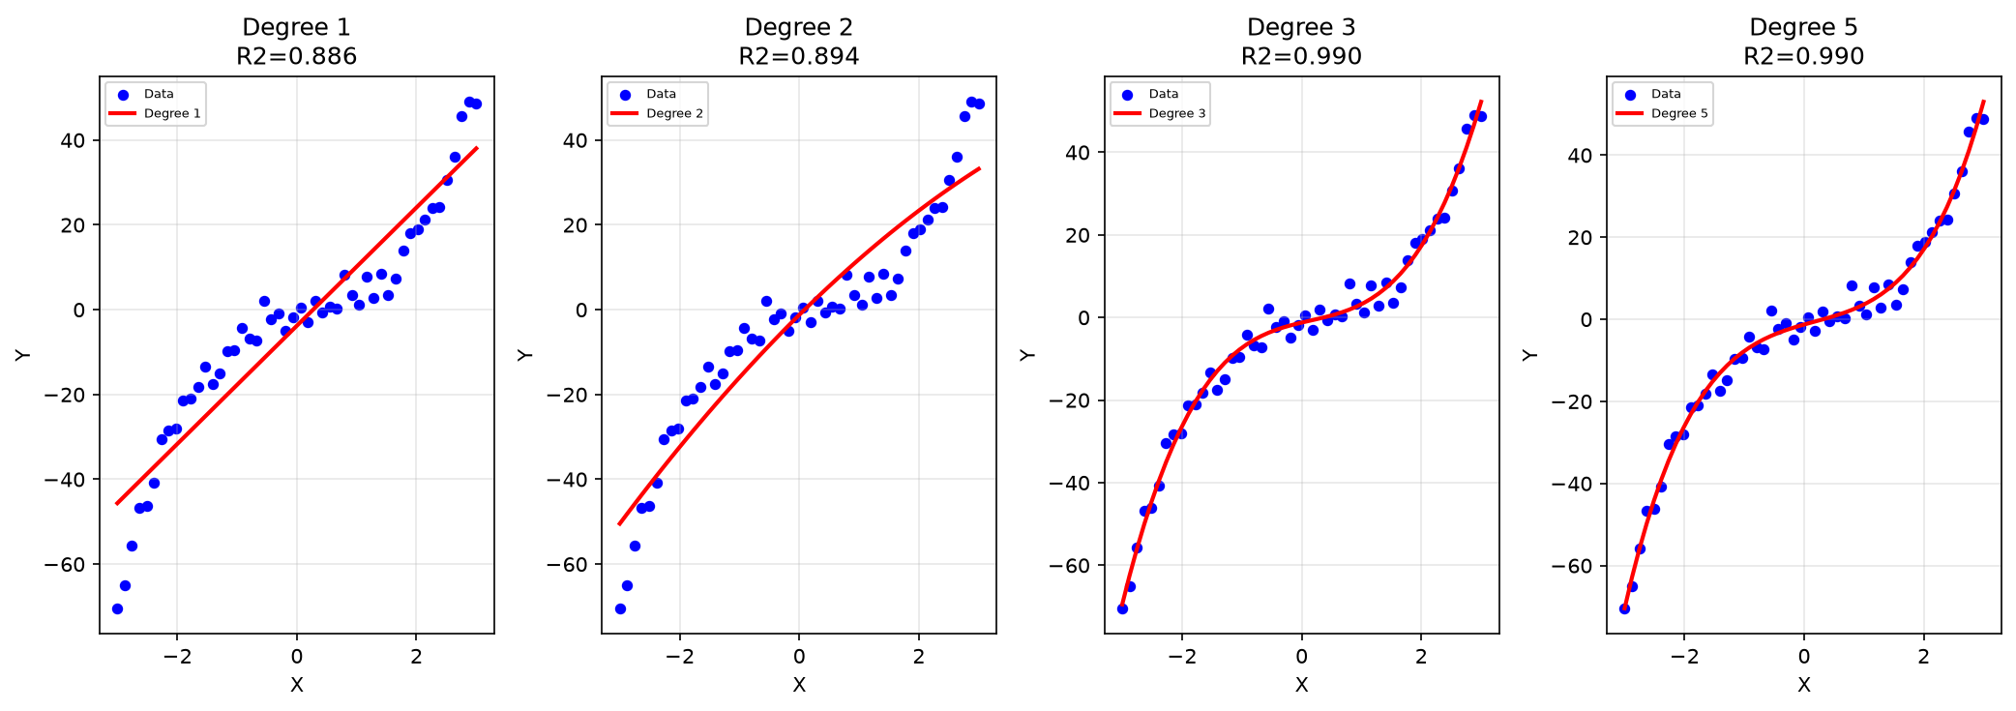

Result: Polynomial Regression curves of degrees 1, 2, 3, and 5 were fitted. Degree 3 gave the best R2 without overfitting.

PRACTICAL NO 7
Aim: To implement Logistic Regression for binary classification and evaluate using accuracy, confusion matrix, precision, recall, and F1-score.
Objective: Apply logistic regression on the Breast Cancer dataset, visualize the confusion matrix.
Code
import numpy as np
import pandas as pd
import matplotlib.pyplot as plt
from sklearn.linear_model import LogisticRegression
from sklearn.model_selection import train_test_split
from sklearn.metrics import accuracy_score, confusion_matrix, classification_report, ConfusionMatrixDisplay
from sklearn.datasets import load_breast_cancer
cancer = load_breast_cancer()
X = pd.DataFrame(cancer.data[:, :2], columns=cancer.feature_names[:2])
y = cancer.target
print("Dataset shape:", X.shape)
print("Class distribution:", np.bincount(y))
X_train, X_test, y_train, y_test = train_test_split(X, y, test_size=0.3, random_state=42)
model = LogisticRegression(max_iter=10000)
model.fit(X_train, y_train)
y_pred = model.predict(X_test)
print("\nAccuracy:", accuracy_score(y_test, y_pred))
print("\nClassification Report:\n", classification_report(y_test, y_pred, target_names=cancer.target_names))
cm = confusion_matrix(y_test, y_pred)
disp = ConfusionMatrixDisplay(cm, display_labels=cancer.target_names)
disp.plot(cmap='Blues')
plt.title('Logistic Regression - Confusion Matrix')
plt.show()

Output:
Dataset shape: (569, 2)
Class distribution: [212 357]
Accuracy: 0.9064327485380117
Classification Report:
precision recall f1-score support
malignant 0.91 0.83 0.87 63
benign 0.90 0.95 0.93 108
accuracy 0.91 171
macro avg 0.91 0.89 0.90 171
weighted avg 0.91 0.91 0.91 171

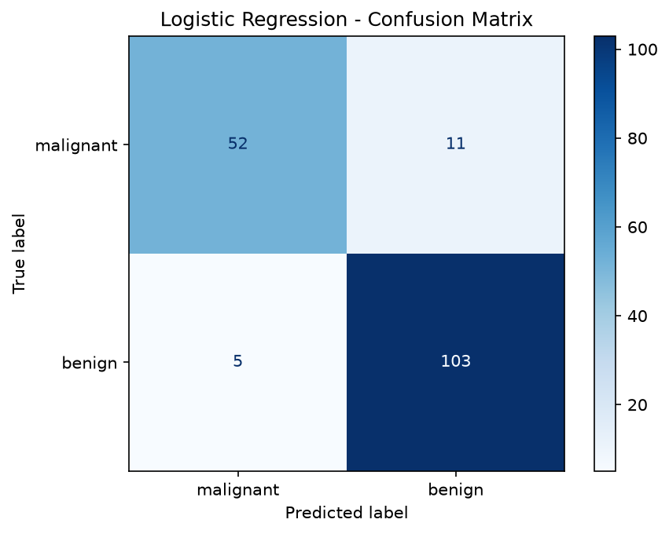

Result: Logistic Regression was applied for binary classification on the Breast Cancer dataset. The confusion matrix and classification report showed good precision, recall, and F1-scores.

PRACTICAL NO 8
Aim: To implement k-NN algorithm for classification and find the optimal value of k.
Objective: Apply k-NN on the Iris dataset, plot accuracy for different k values, and generate the classification report.
Code
import numpy as np
import matplotlib.pyplot as plt
from sklearn.neighbors import KNeighborsClassifier
from sklearn.model_selection import train_test_split
from sklearn.preprocessing import StandardScaler
from sklearn.metrics import accuracy_score, classification_report
from sklearn.datasets import load_iris
iris = load_iris()
X = iris.data[:, :2]
y = iris.target
print("Iris Dataset - Classes:", iris.target_names)
scaler = StandardScaler()
X_scaled = scaler.fit_transform(X)
X_train, X_test, y_train, y_test = train_test_split(X_scaled, y, test_size=0.3, random_state=42)
k_values = range(1, 20)
accuracies = []
for k in k_values:
knn = KNeighborsClassifier(n_neighbors=k)
knn.fit(X_train, y_train)
accuracies.append(accuracy_score(y_test, knn.predict(X_test)))
best_k = list(k_values)[np.argmax(accuracies)]
print(f"Best k: {best_k} with Accuracy: {max(accuracies):.4f}")
knn_best = KNeighborsClassifier(n_neighbors=best_k)
knn_best.fit(X_train, y_train)
y_pred = knn_best.predict(X_test)
print("\nClassification Report:\n", classification_report(y_test, y_pred, target_names=iris.target_names))
plt.figure(figsize=(8, 4))
plt.plot(list(k_values), accuracies, marker='o', color='steelblue')
plt.xlabel('k (Number of Neighbors)')
plt.ylabel('Accuracy')
plt.title('k-NN: Accuracy for Different k Values')
plt.xticks(list(k_values))
plt.grid(True, alpha=0.3)
plt.axvline(x=best_k, color='red', linestyle='--', label=f'Best k={best_k}')
plt.legend()
plt.show()

Output:
Iris Dataset - Classes: ['setosa' 'versicolor' 'virginica']
Best k: 3 with Accuracy: 0.8444
Classification Report:
precision recall f1-score support
setosa 1.00 1.00 1.00 19
versicolor 0.80 0.62 0.70 13
virginica 0.69 0.85 0.76 13
accuracy 0.84 45
macro avg 0.83 0.82 0.82 45
weighted avg 0.85 0.84 0.84 45

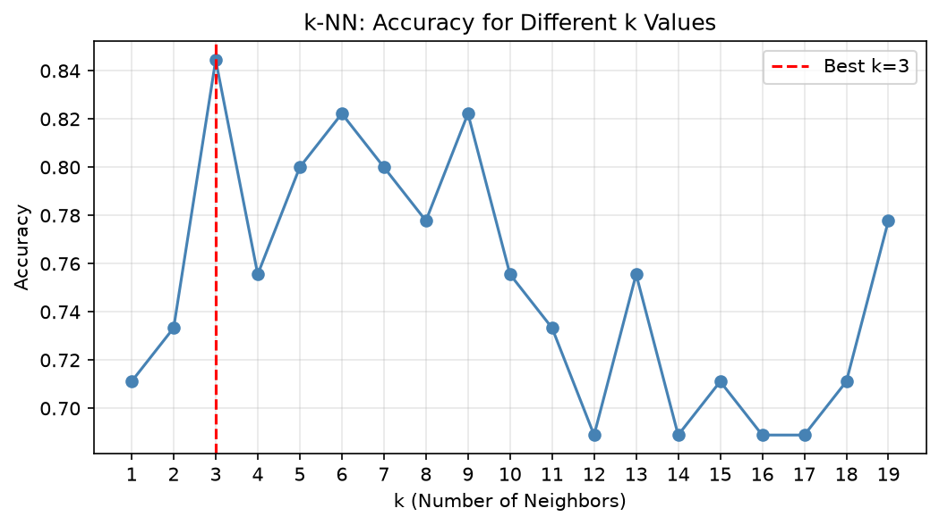

Result: k-NN classifier was implemented on the Iris dataset. The optimal k was found by plotting accuracy for k=1 to 19. Feature scaling improved performance.

PRACTICAL NO 9
Aim: To implement a Decision Tree classifier and visualize the tree structure and feature importances.
Objective: Train a Decision Tree on the Iris dataset, tune max_depth, and analyze feature importances.
Code
import numpy as np
import pandas as pd
import matplotlib.pyplot as plt
from sklearn.tree import DecisionTreeClassifier, plot_tree, export_text
from sklearn.model_selection import train_test_split
from sklearn.metrics import accuracy_score, classification_report
from sklearn.datasets import load_iris
iris = load_iris()
X, y = iris.data, iris.target
feature_names = iris.feature_names
class_names = iris.target_names.tolist()
X_train, X_test, y_train, y_test = train_test_split(X, y, test_size=0.3, random_state=42)
dt = DecisionTreeClassifier(criterion='gini', max_depth=4, random_state=42)
dt.fit(X_train, y_train)
y_pred = dt.predict(X_test)
print("Accuracy:", accuracy_score(y_test, y_pred))
print("\nClassification Report:\n", classification_report(y_test, y_pred, target_names=class_names))
print("\nTree Structure:\n", export_text(dt, feature_names=list(feature_names)))
plt.figure(figsize=(14, 6))
plot_tree(dt, feature_names=feature_names, class_names=class_names, filled=True, rounded=True, fontsize=8)
plt.title('Decision Tree - Iris Dataset')
plt.show()
importances = pd.Series(dt.feature_importances_, index=feature_names)
importances.sort_values().plot(kind='barh', color='steelblue')
plt.title('Feature Importances')
plt.xlabel('Importance Score')
plt.tight_layout()
plt.show()

Output:
Accuracy: 1.0
Classification Report:
precision recall f1-score support
setosa 1.00 1.00 1.00 19
versicolor 1.00 1.00 1.00 13
virginica 1.00 1.00 1.00 13
accuracy 1.00 45
macro avg 1.00 1.00 1.00 45
weighted avg 1.00 1.00 1.00 45
Tree Structure:
|--- petal length (cm) <= 2.45
| |--- class: 0
|--- petal length (cm) > 2.45
| |--- petal length (cm) <= 4.75
| | |--- petal width (cm) <= 1.60
| | | |--- class: 1
| | |--- petal width (cm) > 1.60
| | | |--- class: 2
| |--- petal length (cm) > 4.75
| | |--- petal width (cm) <= 1.75
| | | |--- petal length (cm) <= 4.95
| | | | |--- class: 1
| | | |--- petal length (cm) > 4.95
| | | | |--- class: 2
| | |--- petal width (cm) > 1.75
| | | |--- petal length (cm) <= 4.85
| | | | |--- class: 2
| | | |--- petal length (cm) > 4.85
| | | | |--- class: 2

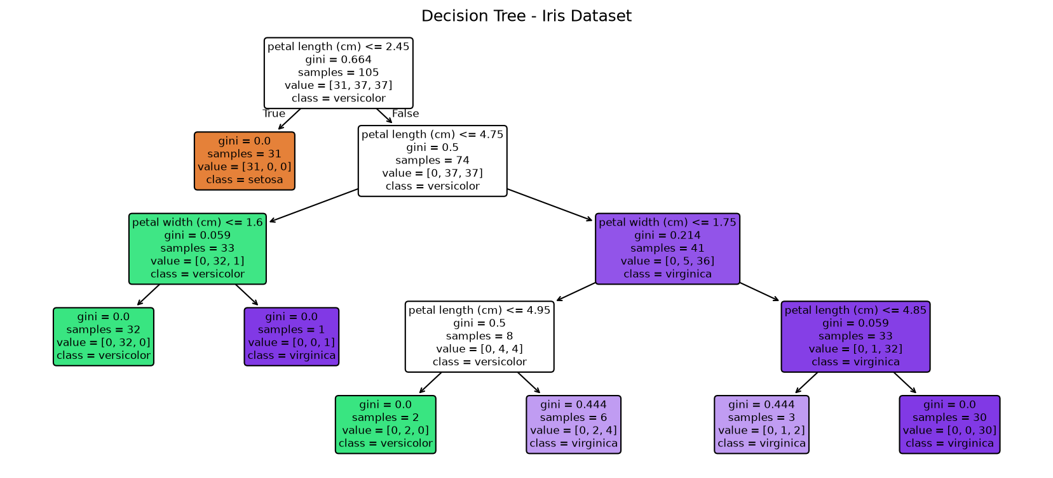

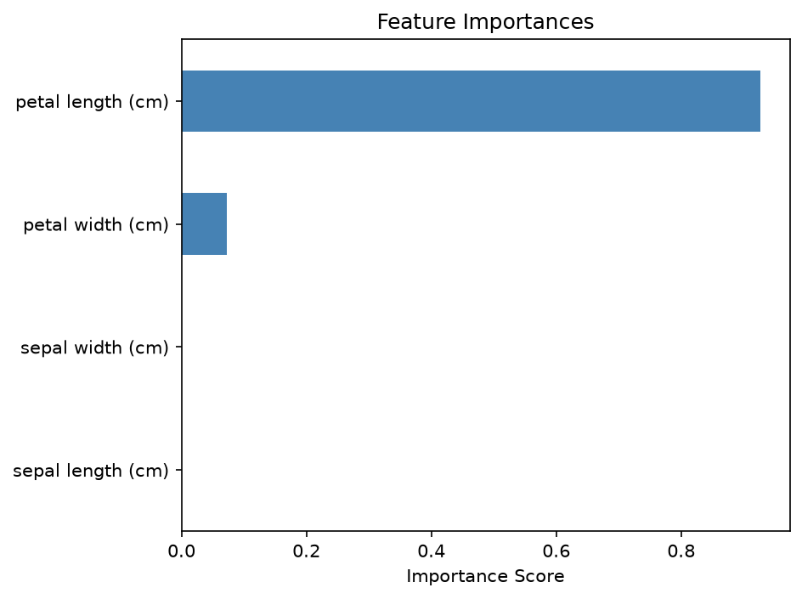

Result: Decision Tree classifier was built with max_depth=4. The tree was visualized. Feature importance plot showed petal length and petal width are the most important features.

PRACTICAL NO 10
Aim: To implement Naive Bayes classification using Gaussian Naive Bayes and evaluate model performance.
Objective: Apply GaussianNB on the Wine dataset and interpret prediction probabilities.
Code
import numpy as np
import pandas as pd
import matplotlib.pyplot as plt
from sklearn.naive_bayes import GaussianNB
from sklearn.model_selection import train_test_split
from sklearn.metrics import accuracy_score, classification_report, confusion_matrix, ConfusionMatrixDisplay
from sklearn.datasets import load_wine
from sklearn.preprocessing import StandardScaler
wine = load_wine()
X = pd.DataFrame(wine.data, columns=wine.feature_names)
y = wine.target
print("Wine Dataset shape:", X.shape)
print("Classes:", wine.target_names)
scaler = StandardScaler()
X_scaled = scaler.fit_transform(X)
X_train, X_test, y_train, y_test = train_test_split(X_scaled, y, test_size=0.3, random_state=42)
gnb = GaussianNB()
gnb.fit(X_train, y_train)
y_pred = gnb.predict(X_test)
print("\nAccuracy:", accuracy_score(y_test, y_pred))
print("\nClassification Report:\n", classification_report(y_test, y_pred, target_names=wine.target_names))
proba = gnb.predict_proba(X_test[:5])
prob_df = pd.DataFrame(proba, columns=wine.target_names)
print("\nPrediction Probabilities (first 5):\n", prob_df.round(4))
cm = confusion_matrix(y_test, y_pred)
disp = ConfusionMatrixDisplay(cm, display_labels=wine.target_names)
disp.plot(cmap='Purples')
plt.title('Gaussian Naive Bayes - Confusion Matrix (Wine)')
plt.show()

Output:
Wine Dataset shape: (178, 13)
Classes: ['class_0' 'class_1' 'class_2']
Accuracy: 1.0
Classification Report:
precision recall f1-score support
class_0 1.00 1.00 1.00 19
class_1 1.00 1.00 1.00 21
class_2 1.00 1.00 1.00 14
accuracy 1.00 54
macro avg 1.00 1.00 1.00 54
weighted avg 1.00 1.00 1.00 54
Prediction Probabilities (first 5):
class_0 class_1 class_2
0 1.0 0.0000 0.0000
1 1.0 0.0000 0.0000
2 0.0 0.0018 0.9982
3 1.0 0.0000 0.0000
4 0.0 1.0000 0.0000

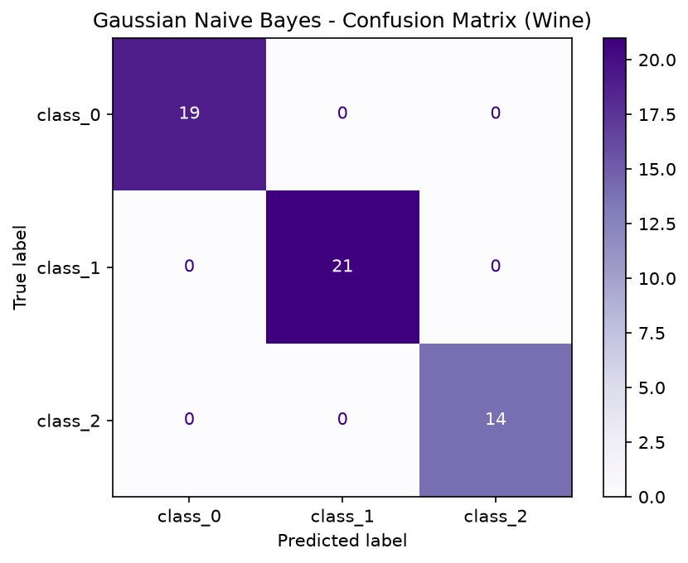

Result: Gaussian Naive Bayes classifier was applied on the Wine dataset. High accuracy was achieved. The confusion matrix showed minimal misclassifications.

PRACTICAL NO 12
Aim: To implement the Random Forest ensemble classifier and compare its performance with a single Decision Tree.
Objective: Train Random Forest with multiple trees, analyze feature importances, and compare with Decision Tree accuracy.
Code
import numpy as np
import pandas as pd
import matplotlib.pyplot as plt
from sklearn.ensemble import RandomForestClassifier
from sklearn.tree import DecisionTreeClassifier
from sklearn.model_selection import train_test_split
from sklearn.metrics import accuracy_score, classification_report
from sklearn.datasets import load_wine
wine = load_wine()
X, y = wine.data, wine.target
feature_names = wine.feature_names
X_train, X_test, y_train, y_test = train_test_split(X, y, test_size=0.3, random_state=42)
dt = DecisionTreeClassifier(random_state=42)
dt.fit(X_train, y_train)
dt_acc = accuracy_score(y_test, dt.predict(X_test))
print(f"Decision Tree Accuracy: {dt_acc:.4f}")
rf = RandomForestClassifier(n_estimators=100, max_depth=None, oob_score=True, random_state=42)
rf.fit(X_train, y_train)
rf_pred = rf.predict(X_test)
rf_acc = accuracy_score(y_test, rf_pred)
print(f"Random Forest Accuracy: {rf_acc:.4f}")
print(f"OOB Score: {rf.oob_score_:.4f}")
print("\nClassification Report:\n", classification_report(y_test, rf_pred, target_names=wine.target_names))
estimators = [10, 20, 50, 100, 200]
accs = []
for n in estimators:
rf_n = RandomForestClassifier(n_estimators=n, random_state=42)
rf_n.fit(X_train, y_train)
accs.append(accuracy_score(y_test, rf_n.predict(X_test)))
plt.figure(figsize=(7, 4))
plt.plot(estimators, accs, marker='o', color='darkgreen')
plt.xlabel('Number of Trees')
plt.ylabel('Accuracy')
plt.title('Random Forest: Trees vs Accuracy')
plt.grid(True, alpha=0.3)
plt.show()
importances = pd.Series(rf.feature_importances_, index=feature_names)
importances.nlargest(8).sort_values().plot(kind='barh', color='steelblue')
plt.title('Top 8 Feature Importances (Random Forest)')
plt.tight_layout()
plt.show()

Output:
Decision Tree Accuracy: 0.9630
Random Forest Accuracy: 1.0000
OOB Score: 0.9839
Classification Report:
precision recall f1-score support
class_0 1.00 1.00 1.00 19
class_1 1.00 1.00 1.00 21
class_2 1.00 1.00 1.00 14
accuracy 1.00 54
macro avg 1.00 1.00 1.00 54
weighted avg 1.00 1.00 1.00 54

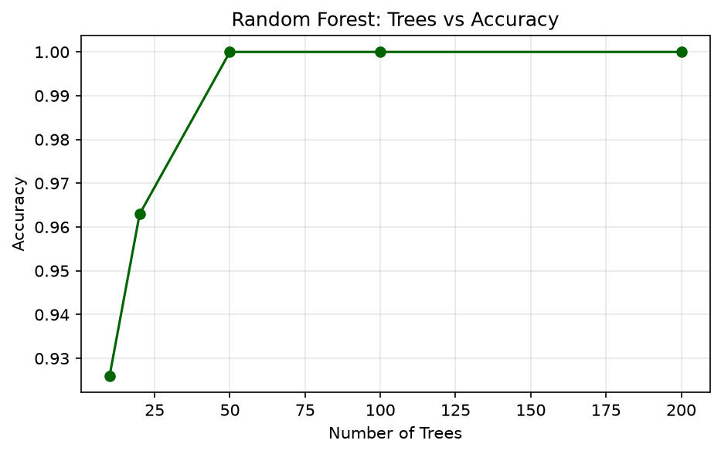

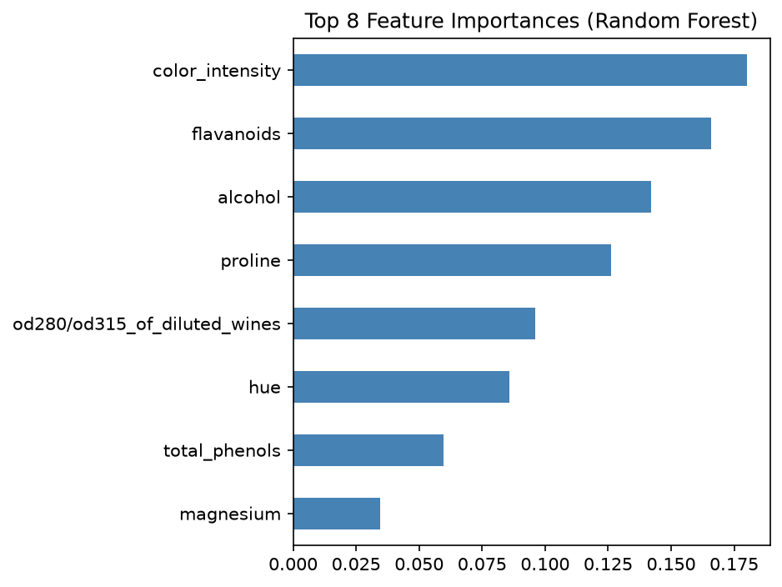

Result: Random Forest outperformed single Decision Tree due to ensemble averaging. Feature importance plots revealed the most significant wine attributes.

